CG Assignment 1

21K-3153

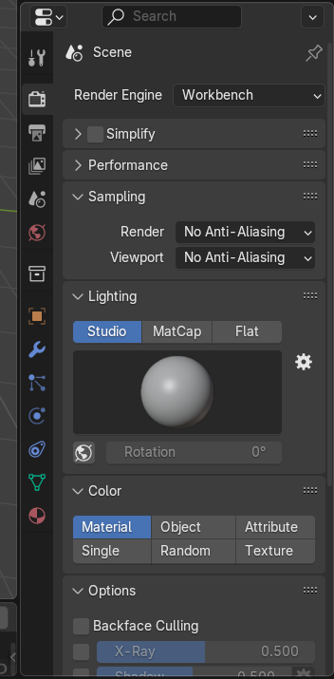

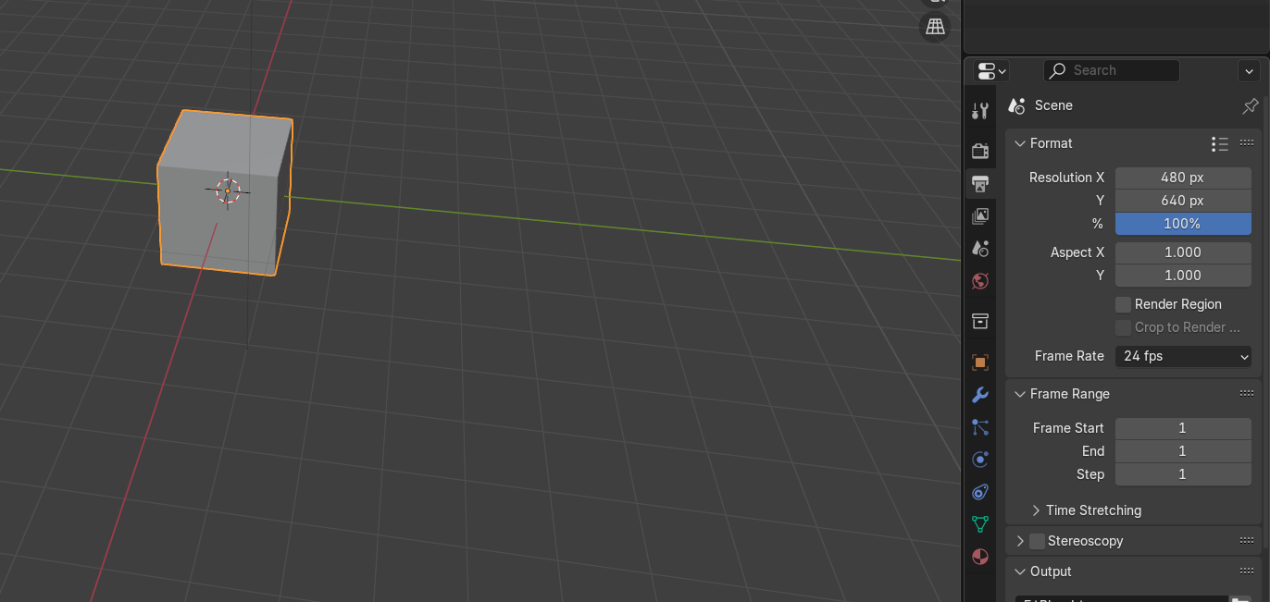

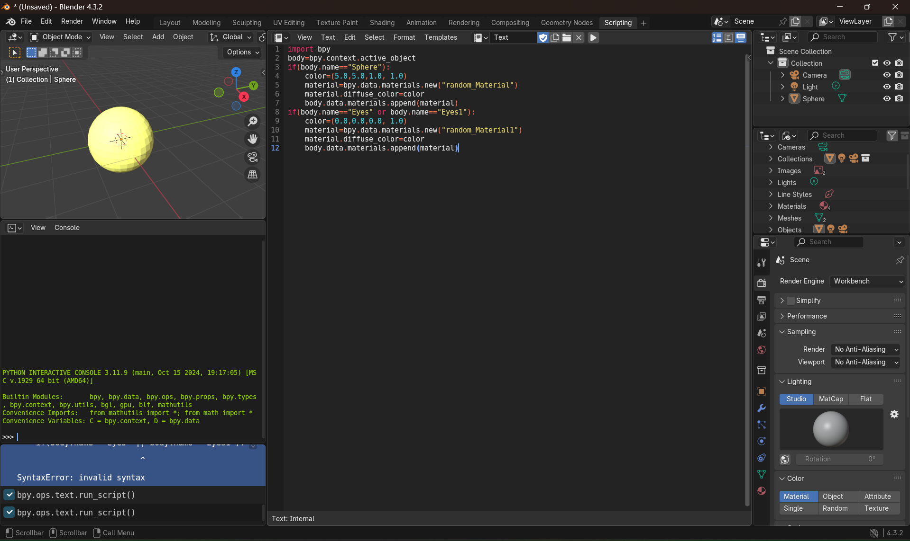

OPENGL :

When the code is run, a **colored ellipse** will be drawn on a **white background**, centered at **(250, 250)** with a **horizontal radius of 100** and a **vertical radius of 125**. The ellipse is generated using the **Midpoint Ellipse Algorithm**, and its color randomly changes during different stages of drawing. The window size is **640x480 pixels** and the ellipse is displayed as a collection of points rather than a continuous shape.